**Create a website**

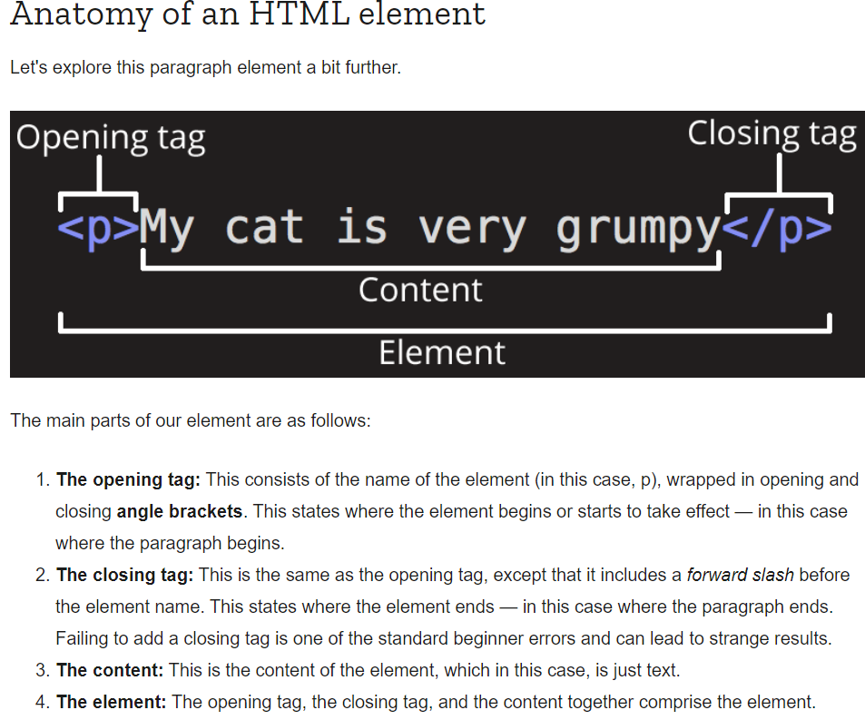What is HTML: HyperText Markup Language

Code used to structure a webpage and its content.

Images Folder

* Images for site

Styles Folder

* Contains CSS code used to style content (text and background colors)

Scripts Folder

* JavaScript code (eg buttons that load data when clicked)

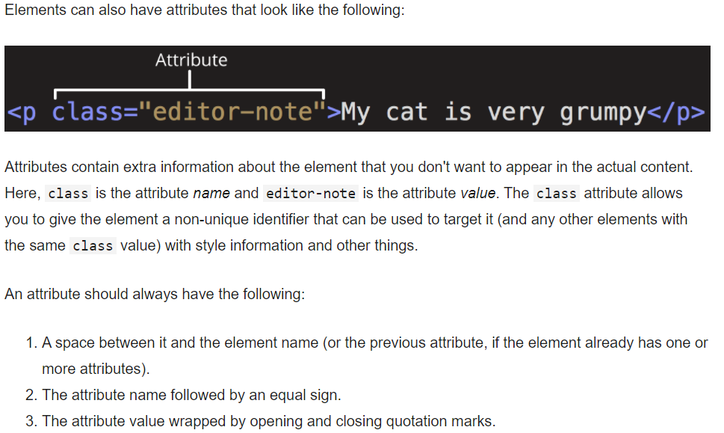

Note on Attributes:

Imbedding an image needs no </img> closing tag because we are just imbedding the image in the place it appears.

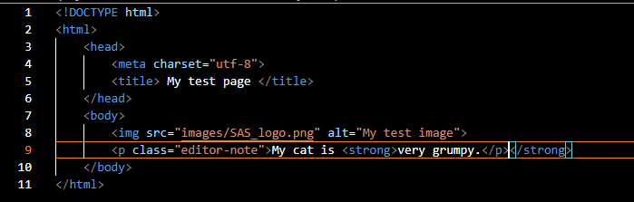

<!DOCTYPE html>: required preamble

<html> </html>: root element. Wraps all the content up.

<head> </head>: container for stuff in webpage that won’t be visible. Keywords, page description to appear in search results, CSS to style content, character set declarations….

<meta charset=”utf-8”> : sets the character set n document to UTF-8, lets the page handle any textual content.

<title> </title>: title that appears in browser tab the page is loaded in. describes the page when bookmarked.

<body> </body>: all the content to show in web, text, images, videos, games etc.

<img src=”pathname” alt=”My test image”>: embeds image into page in position it appears.

Attribute “SRC” is the source attribute

Attribute “ALT” is the alternative attribute 🡪 what to show if the image cannot be loaded..descriptive text

<p> </p>: set a paragraph of text.

<h1> </h1>: create a heading with different font in the body of the page. Can have up to 6 headings <h6>

<ul> : Unordered list element (like a shopping list)

<ol> : Ordered list, like a recipe

NOTE: <li> </li> is the LIST ITEM that must follow each point in the text

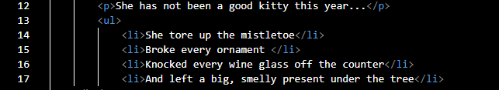

<a> element for adding a LINK